**Follow the instructions here below.**

**LAB 1 – Part 1**

Create this simple synthesizer below using the file “Lab1 - Part 1-DEMO.maxpat”.

The patch has detailed instructions on the right side. You may also follow along with this step-by-step video that shows you how to make it and provides a guidance in working in the Max/MSP.

Lab 1 Part 1Video link:

<https://media.ucsc.edu/V/Video?v=4085763&node=13878351&a=107298746&autoplay=1>

**Due: turn in a screen shot of your finished patch and name it as follows: “lastname firstname lab 1 part 1” Please also include a comment with your name in the patch.**

Follow the video and the extensive comments within the patch to guide you to make this patch pictured below (next page).

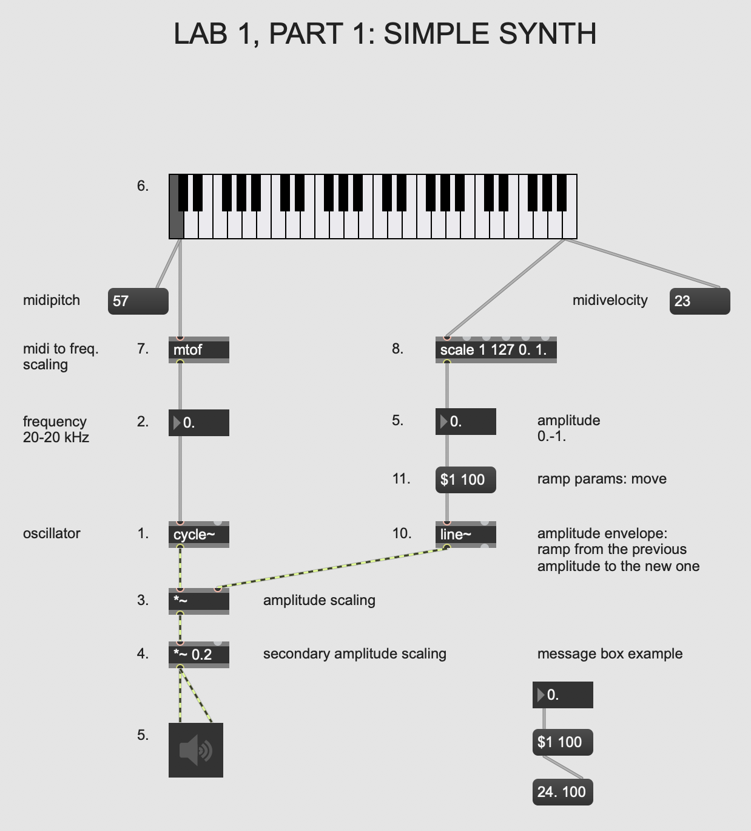

**LAB 1 – Part 2**

Create this simple synthesizer below using the file “Lab1 - Part 2-DEMO.maxpat”

**Due: turn in a screen shot of your finished patch and name it as follows: “lastname firstname lab 1 part 2”. Please also include a comment with your name in the patch.**

Lab 1 Part 2 Video link:

<https://media.ucsc.edu/V/Video?v=4086296&node=13880413&a=52642495&autoplay=1>

Follow the video demonstration and the extensive comments within the patch to guide you to make this patch pictured below.

Then, follow the instructions in Lab 1, Part 3 **BEFORE** closing this patch.

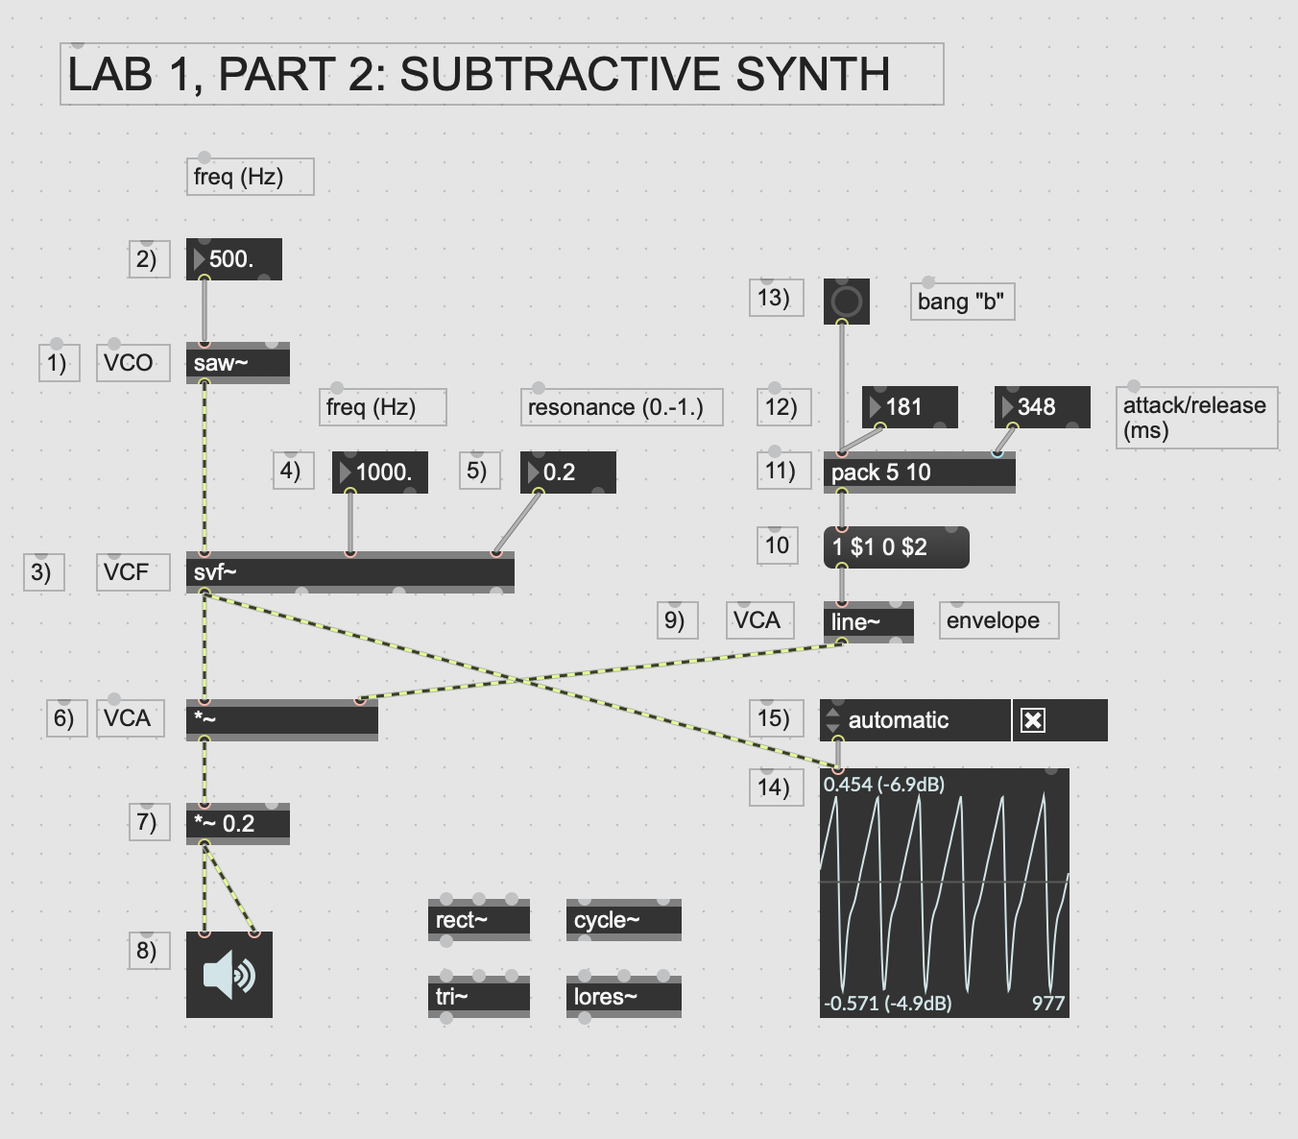

**LAB 1 – Part 3**

**Due: Answer the questions below and turn in the answers in a document labeled as follows: “lastname firstname lab 1 part 3”. Please save your document as a pdf.**

1. Explore your subtractive synth by trying out different values for the parameters of:

VCO (frequency in Hz.),

VCF (frequency in Hz.)

VCF resonance (0.-1. range of values)

and envelope parameters for attack (ms.)

and release (ms.) times

**Write down one set of values for all of these parameters above that is appropriate to make sound and sounds good to you.**

2. **If the time of the attack is set to 0 seconds how does it sound? Why do you think this is?**

3. Change out the VCO with the cycle~, tri~ and rect~ waveforms. **How would you characterize the sound of the saw~ as VCO compared with the cycle~ as VCO? Why do you think that the saw waveform is more appropriate for subtractive synthesis than a sinewave?**

4.Alter the filter resonance to test values around 0.0, 0.5, and 0.9. Also, change the filter frequency at each resonance value. **Describe in a subjective way how the the filter resonance affects the sound**.

**LAB 1 – Part 4**

Lab 1 Part 4 Video link:

[**https://media.ucsc.edu/V/Video?v=7119061&node=30041632&a=213445286&autoplay=1**](https://media.ucsc.edu/V/Video?v=7119061&node=30041632&a=213445286&autoplay=1)

Open the file: Lab1-Part 3-Master.maxpat

**Experiment with the same synthesizer patch using a sequencer that is already built into the program for you. You don’t need to do any programming, just follow the video and explore this patch for yourself.**